
What is Brucella abortus RB51?
Health Information for Individuals Potentially Exposed to Brucella abortus RB51 from Raw Dairy Products
Brucella abortus is a bacteria that primarily causes infection and pregnancy loss in cattle. It can also cause disease in humans when they come into contact with sick animals or consume contaminated dairy products. The strain you were potentially exposed to, RB51, is a drug-resistant type that is harder to detect and treat.
The bacteria can take anywhere from 5 days to 6 months to cause illness in someone who was exposed. Based on this, individuals who have been exposed should monitor themselves for symptoms for 6 months starting from the date they were last exposed.
What should I look out for?
Initial symptoms: If the illness is not treated or comes back, you may have problems like:
Fever Low appetite Swelling of the heart, liver, and/or spleen Chronic tiredness
Sweating Muscle and joint pain Swelling of the testicle and scrotum area Depression
Weakness Headache Neurologic symptoms (5% of cases) Recurrent fevers
Tiredness Arthritis

What should I do if I have symptoms?
If you become ill with any of the symptoms listed above, please contact your healthcare provider and let them know you were potentially exposed to contaminated dairy products or cattle with B. abortus RB51. Take this flyer with you to your healthcare provider visit, as it will provide information on how they can work with your local health department to arrange for testing and treatment.

Information for your Healthcare Provider:
Laboratory Testing: The Centers for Disease Control and Prevention (CDC) recommends that all symptomatic individuals who were exposed to Brucella abortus RB51 be tested with a blood culture. Collect 10-20 mL of whole blood in a purple top tube (EDTA) for testing. Please contact your local district investigator to coordinate shipment to the state public health laboratory. Specimens should be shipped at 38ºF on frozen ice packs and clearly mark that the shipping container includes a Category B Biological Substance.
Treatment Recommendations: Exposed individuals who are asymptomatic or who are symptomatic but negative on blood culture should receive post exposure prophylaxis with doxycycline & trimethoprim/sulfamethoxazole for 21 days.
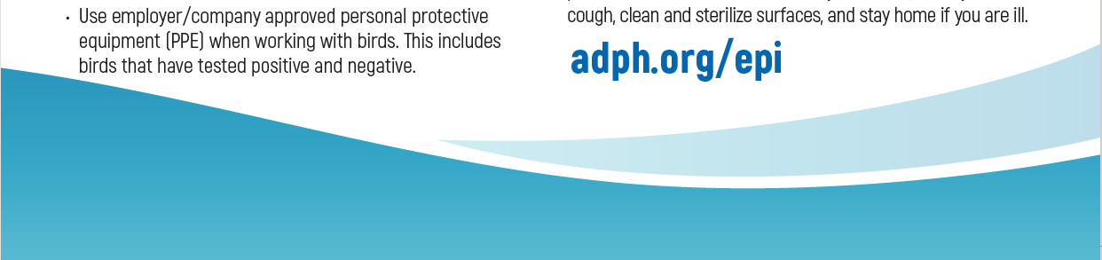
Exposed individuals who are positive on blood culture should be treated with antibiotics based on antimicrobial susceptibility results as B. abortus RB51 is resistant to rifampin and penicillin.
If you have any questions or concerns, please contact the Alabama Department of Public Health:
800-338-8374 – Toll Free

